Disease prediction with sensor data using IOT and Machine Learning
A project report submitted in partial fulfillment of the requirements
for the award of the degree of
MASTER OF COMPUTER APPLICATIONS
By
MANKALA VENKATA SUDARSAN
20VV1F0010
Under the Esteemed Guidance of
Dr. G. JAYA SUMA, M. Tech, Ph.D.
Professor
Department of Information Technology

DEPARTMENT OF INFORMATION TECHNOLOGY
JAWAHARLAL NEHRU TECHNOLOGICAL UNIVERSITY
GURAJADA VIZIANAGARAM
COLLEGE OF ENGINEERING
VIZIANAGARAM – 535003, A.P.2021-2022
DEPARTMENT OF INFORMATION TECHNOLOGY
JNTU - GV COLLEGE OF ENGINEERING
VIZIANAGARAM
CERTIFICATE

This is to certify that the project report entitled “Disease prediction with sensor data using IOT and Machine Learning” that is being submitted by MANKALA VENKATA SUDARSAN(20VV1F0010) in partial fulfillment for the award of Degree of Master of Computer Applications(MCA) in the department of INFORMATION TECHNOLOGY from Jawaharlal Nehru Technological University Kakinada - University College of Engineering Vizianagaram is a record of bonafide work carried out by her under my guidance and supervision in this department during the year 2020 - 2021.
The results embodied in this report have not been submitted to any other University or Institute for the award of any degree or diploma.

Signature of Project Guide Signature of Head of the Department

Dr. G. JAYA SUMA Dr. G. JAYA SUMA
Professor & Head Professor & Head
Dept. of Information Technology Dept. of Information Technology
JNTUK – UCEV JNTUK – UCEV

(Signature of External Examiner)

DECLARATION

I, MANKALA VENKTA SUDARSAN (Reg.No:20VV1F0010) declare that this written submission represents my ideas in my own words and where others ideas or words have been included, I have adequately cited and referenced the original sources. I also declare that I have adhered to all principles of academic honesty and integrity and have not misrepresented or fabricated or falsified any idea data fact source in my submission. I understand that any violation of the above will be cause for disciplinary action by the institute and can also evoke penal action from the sources which have thus not been properly cited or from whom proper permission has not been taken when needed.

(Signature)

MANKALA VENKATA SUDARSAN
(20VV1F0010)
Place:
Date:

ACKNOWLEDGEMENT

This acknowledgement transcends the reality of formality when I express deep gratitude and respect to all those people behind the screen who inspired and helped us in completion of this project work.I take the privilege to express my heartfelt gratitude to my guide Dr. G. JAYA SUMA Professor & HOD, Department of Information Technology, JNTUK University College of Engineering Vizianagaram for her valuable suggestions and constant motivation that greatly helped me in successful completion of the project. Wholehearted cooperation and the Keen interest shown by her at all stages are beyond words of gratitude.With great pleasure and privilege, I wish to express my heartfelt sense of gratitude and indebtedness to Professor, Head of Department of Information Technology, JNTU-GV Vizianagaram, for her supervision. I extend heartfelt thanks to our Principal Prof. K.SRIKUMAR, Principal of JNTU-GV University College of Engineering Vizianagaram, for providing me with a good infrastructure and environment to carry out this project.I am also thankful to all the Teaching and Non-Teaching staff of Information Technology Department, JNTUK University College of Engineering Vizianagaram, for their direct and indirect help provided to me in completing the project. Finally, I am extremely thankful to my parents and friends for their constant help and moral support.

MANKALA VENKATA SUDARSAN
20VV1F0010

ABSTRACT

One of the first steps in treating a sickness, whether it be a cold or cancer, is the detection of the illness. Disease detection is mainly based on symptoms, some of which may be universal..
When an illness is being treated, early discovery is frequently viewed as the first step toward success. Though disease detection may appear to be a basic and uncomplicated process, it is actually a very sophisticated game. The difficulty of identifying diseases and determining whether the recommended treatment is effective arises from the fact that many diseases have similar symptoms. Additionally, a patient must undergo a battery of tests in order to be diagnosed with a condition, which can be time-consuming and expensive.
- Numerous illnesses with widespread symptoms
- Patients' unfamiliarity with the terminology used by doctors to describe their precise symptoms
- Early detection of human error is a challenge for medical professionals, and getting a second opinion takes time.
Therefore, it's crucial to correctly identify an illness in order to choose the best course of action for treating it.

LIST OF FIGURES
fig1.1:health monitoring system………………………………………………. 11

Fig2.1.Workflow for the implementation………………………………… 19

Fig1.34.1 .Knn classifier ………………………………………..………….…. 20
Fig1.5.1.navie bayes probability classifier………………….……………… 21
fig1.6.1 .svm classifier……………………………...…………… 22
Fig1.6. 2 hyperplane……………………………………..………… 23

Fig1.6.3: SVM linear data…………………………………………………… 24

Fig1.6.4.SVM Nonlinear data……………………………………………… 24
Fig1.7.1: decision tree for play tennis…………………………………… 25
Fig 3.1 max30102 sensor………………………………………… 32
Fig 3.2: Pin out for the MAX30102 sensor………………………………… 33
Fig 3.3: collect the data from sensor……………………………………….. 35

Fig 3.4. MAX30102 Sensor Module – Parts……………………………… 35
Fig 3.5:MAX30102 Sensor Module Circuit Diagram…………………… 36

Fig 3.6: MAX30102 Sensor not Working…………………….… 37
Fig 3.7Arduino USB 2.0 Cable……………………………………………… 37
Fig 3.8. Jumper wires (generic)……………………….…… 38
Fig 3.9 Breadboard(generic)…………………………………………..…… 39
Fig 3.10: arduino IDE 1.8.19………………………………………..… 42
Fig 3.10:thingspeak channel…………………………………….…………… 44
Fig 4.1:board and sensor interface……………………………….……… 46
Fi4.2: connect the board to thingspeak………………………………………. 46
Fig 4.3 max30102 and the esp32 board are connected in a black schematic… 47
Fig 4.4:Data send to thingspeak & jupyter…………………………… 47
Fig 4.5: i2c protocol…………………………………………………………… 48
Fig 4.6 ip protocol………………………………………………… ……….… 48
Fig 7.1 : data transformation from sensor to notebook…………. 64

TABLE OF CONTENTS
S.NO | Chapter Name | Page No
 | Abstract  List Of Figures | 5  6-7
1 | Introduction  - Introduction to disease prediction  - Introduction to IOT  - Introduction to Machine Learning  - K - Nearest Neighbour(KNN)  - Navie bayes  - Support Vector Machine Algorithm  - Decision Tree Algorithm | 9-26
2 | Literature Survey | 27-28
3 | Software And Hardware Requirements | 29-44
4 | Methodology | 45-48
5 | Problem Statement | 49-51
6 | Implementation | 52-62
7 | Result And Analysis | 63-66
8 | Conclusion And Future Scope | 67-68
9 | References | 69-70

Chapter 1

INTRODUCTION

INTRODUCTION:
1.1 Introduction to disease prediction
Every area of life, from how we live to how we work to how we interact with others, has undergone constant change thanks to the internet of things. There are IOT-enabled desks, intelligent lighting, smart drinks, and just about anything else.
As the total number of IoT devices is predicted to quadruple from 8.74 billion in 2020 to over 25.4 billion by 2030, this rapid growth will continue. For organisations, this connectivity has paved the door for "smart offices," the workplace of the future.
IOT technologies are being used by intelligent offices to change the way that business is conducted. But what tangible advantages can it offer for the workplace? What obstacles exist, and how might IOT be used to create a smart office? These queries will be addressed in this essay, along with the subject of whether or not smart workplaces are necessary.

Smart offices are becoming more common. Grand View Research, Inc. estimates that in 2016, the global smart office market had a value of $18.46 billion. The industry is anticipated to increase at a CAGR of 13.2% from 2017 to 2025, reaching $57.05 billion. Rapid technological breakthroughs in fields like IOT and the growing demand for sustainable methods of managing IT resources are the main causes of this increase.increasing number

When predicting the likelihood of a specific result, such as whether or not a client would churn in 30 days, prediction refers to the output of an algorithm after it has been trained on historical data and applied to current data. For every record in the new data, the algorithm will produce probable values for an unknown variable, enabling the model builder to determine what that value will most likely be.

Prediction is not always accurate. When you use machine learning to choose the next best step in a marketing campaign, for example, you are effectively anticipating a future outcome. Other times, though, the forecast focuses on things like whether or not a transaction will occur.

The approach known as "disease prediction using machine learning" uses symptoms provided by patients or other users to make disease predictions. The user's symptoms are processed by the algorithm, which then outputs the likelihood that the user will develop the condition. The supervised machine learning method known as the Naive Bayes classifier is utilised in the disease prediction process. The Nave Bayes method determines the likelihood of the disease. Accurate analysis of medical data helps with early illness identification and patient care as biological and healthcare data volumes rise. We are forecasting diseases including Diabetes, Malaria, Jaundice, Dengue, and Tuberculosis using linear regression and decision trees.

Modern day uses of machine learning include
Facebook employs machine learning to individually tailor each user's feed. The recommendation engine will start to display more of that group's activity sooner in the feed if a member regularly pauses to read the posts in that group.
The engine is working behind the scenes to reinforce recognised patterns in the member's online behaviour. The news feed will modify itself if the member's reading habits change and they neglect to view postings from that group in the upcoming weeks.
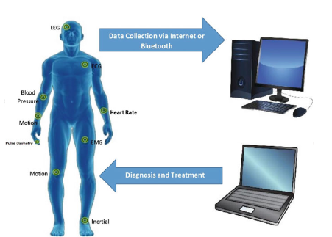
fig1:health monitoring system
Other applications for machine learning outside of recommendation engines include the following::
Relationship management with customers. Machine learning models can be used by CRM software to analyse email and remind sales team members to reply to the most crucial communications first. Even prospective solutions can be recommended by more sophisticated systems.
Enterprise intelligence.
In order to recognise potentially significant data points, trends of data points, and anomalies, BI and analytics suppliers include machine learning into their software.
Information systems for human resources.
To go through applications and find the top prospects for a post, HRIS systems can apply machine learning models.
Autonomous vehicles.
Even a semi-autonomous automobile may be able to distinguish a partially visible item and notify the driver thanks to machine learning algorithms.
Virtual helpers.
In order to understand normal speech and provide assistance, smart assistants often blend supervised and unsupervised machine learning models.
1.2 Internet of Things :
In order to monitor the performance of devices connected to the Internet of Things, sensors are used in IOT data collecting.
By gathering and transmitting real-time data that can be stored and retrieved at any time, the sensors keep tabs on the state of the IOT network.

Types of IOT Data Collection

Equipment Data
This kind of information relates to the condition of IOT devices. Real-time equipment data collection enables predictive maintenance actions.
Data scientists don't have to be the only ones who use predictive maintenance. Learn how to use Ubidots and machine learning for PdM by watching this video.
As a result, it saves the system lots of energy costs while enhancing machine productivity and longevity

Data about equipment should be consolidated at a single location and made accessible to line employees, tactical management, and top executives to increase its usefulness.

Submeter Data

In multi-user scenarios, submetering enables property owners to automate the

measurement of individual utility usage.

In buildings where several tenants use utilities like water, electricity, gas, or cable, submeter data can be gathered.

Digital measuring instruments speed up the invoicing process and decrease measurement errors.

Environmental Data
IoT sensors can measure and keep track of environmental information like::
- humidity
- temperature
- movement
- air quality

IOT Data Collection Works

In order for the IOT data collection process to function, several levels must interact.

Device Layer
The fundamental layer of the IOT architecture is made up of connected devices. These gadgets include of environmental data tracking sensors, bluetooth gadgets, low-power radio-based gadgets, actuators, etc.
The following identities can be applied to IOT devices:

UUID is a built-in, chip-like unique identification that is installed inside of a device. Another type of UUID is one that relies on radio IOT data collecting systems, such as Bluetooth and Wi-Fi MAC.

A Refresh/Bearer token; an identifier stored in the system's programmable non-volatile memory (EEPROM);

Communication Layer
This layer enables devices to communicate using protocols like:
- Even low-end 8-bit devices that support text-based protocols can use HTTP/HTTPS.
- MQTT is a protocol that was created for embedded systems and enhanced for the Internet of Things. It is renowned for having a sizable following and a substantial asset collection.
- CoAP is a protocol with a larger footprint that is based on HTTP semantics. CoAP has worse library support and is more challenging to connect to firewalls than MQTT..

IT Edge Layer
Your IoT devices' operating system, software, and hardware make up this layer..

It is in charge of reading sensors that are attached to a device and altering a gadget's state, such as when a voice command is detected.

Event Processing Layer
Data gathered from IoT devices is processed and stored in this layer.
In this tier, further procedures include:
- cleansing data
- organising data insights adding
- metadata to IoT data

A server-side programme like a JAX RS tool that is database-driven can be used to build the event processing layer.

To handle and store IoT data, you may also establish this layer utilising IoT cloud services

Client Communication Layer
Data is transferred from the device to the user through this layer. It serves as a link between databases on the back end and user interfaces on the front end.
Machine-to-machine APIs that transmit iot insights to a user via a web or mobile application are how this data leaves the system.
All these complex layers of technology come with challenges that businesses must get beyond for a variety of reasons. Below are a few of them.

Challenges of IoT Data Collection

Security

Security is a top priority at all times, including during the data collecting, processing, and storage phases. A lot of the data involved may be sensitive, thus great care must be taken to protect it from intrusion.

Compatibility
IoT systems' architectures and protocols are incredibly diverse. Data from sensors and information from specialised Internet of Things (IoT) devices may not be supported by many tools..

Large Data Sets
Huge volumes of data streams are often collected during IoT data collection. Additionally, this data must be prepared in order for teams to extract some valuable insights from it.
Due to this, adaptable solutions that improve data collection, storage, processing, and extrapolation are required.

Consistency

Keeping your IoT network's gadgets in constant communication is expensive. Other tasks like information processing, storing, and proactive feedback mechanisms are difficult to carry out continuously on a regular basis.

The Importance of IoT Data Collection

1.Better User Experience
You can better understand your end users' wants and behaviours by using automated IoT data collecting. You have a better understanding of how your service or product is actually used as you gather data and form conclusions.
For instance, if your sensory data reveals that your facial recognition software has to be adjusted if it takes an average of four scans to open a device in low ambient light.
You get to understand your end-habits user's by repeatedly reviewing user data and reconstructing your algorithms based on these reports. In the end, this puts you in a better position to help them.

2. Asset Maintenance

Developers and managers can keep an eye on the condition of a particular piece of infrastructure or equipment thanks to live data. As a result, any severe wear and tear can be anticipated, allowing for timely repairs.

This has the advantage of preserving the asset, preventing unnecessary replacements, and lowering replacement costs.

3. Efficient Use of Resources
Automated data collecting aids in the process of making informed decisions. In addition to managing your assets using real-time data that greatly reduces uncertainty, you get to operate on the basis of preset standards.
Your equipment lasts longer because breakdowns are anticipated and maintenance is performed in a timely manner.

4. Synergy in Systems
A typical Internet of Things system has multiple parts. Even if they might work well separately, as a whole, there might be some unanticipated hitches. These drawbacks are lessened by iot data collecting, which identifies faults and their causes, especially before they occur.
This information aids you in evaluating the overall effectiveness of your IoT system holistically.

1.3 Machine Learning
With the use of machine learning (ML), which is a form of artificial intelligence (AI), software programmes can predict outcomes more accurately without having to be explicitly instructed to do so. In order to forecast new output values, machine learning algorithms use historical data as input.

Machine learning is frequently used in recommendation engines. Other common applications include business process automation (BPA), predictive maintenance, spam filtering, malware threat detection, and fraud detection..

Machine learning important
Machine learning is significant because it aids in the development of new goods and provides businesses with a picture of trends in consumer behaviour and operational business patterns. A significant portion of the operations of many of today's top businesses, like Facebook, Google, and Uber, revolve around machine learning. For many businesses, machine learning has emerged as a key competitive differentiation.

Types of machine learning

The way in which a prediction-making algorithm learns to improve its accuracy is a common way to classify traditional machine learning. There are four fundamental

supervised learning, unsupervised learning, semi-supervised learning, and reinforcement learning are among the methods. The kind of data that data scientists wish to predict determines the kind of algorithm they use.
Supervised learning:
For this sort of machine learning, data scientists describe the variables they want the computer to look for correlations between and provide the algorithms with labelled training data. The algorithm's input and output are both described.
Unsupervised learning:
Algorithms used in this sort of machine learning are trained on unlabeled data. The algorithm searches through data sets in search of any significant relationships. Both the input data that algorithms use to train and the predictions or suggestions they produce are predefined.
Semi-supervised learning:
These two forms of machine learning are combined in this method. An algorithm may be fed mostly labelled training data by data scientists, but the algorithm is allowed to explore the data on its own and come to its own conclusions about the data set.
Reinforcement learning:

Reinforcement learning is frequently used by data scientists to train a system to finish a multi-step process with well-defined criteria. An algorithm is programmed by data scientists to fulfil a goal, and they provide it with positive or negative feedback as it determines how to do so. However, the algorithm typically chooses the course of action on its own.

Supervised machine learning work
The data scientist must train the algorithm with both labelled inputs and desired outputs in supervised machine learning. For the following tasks, supervised learning algorithms are effective:
- Binary classification: involves separating data into two groups.
- Multi-class classification: Selecting from among more than two different sorts of responses..
- Regression modeling: Predicting continuous values using regression modelling..
- Ensembling: integrating the predictions of various machine learning models to generate a precise prediction.

Unsupervised machine learning work
Algorithms for unsupervised machine learning don't need labels on the input data. They sort through unlabeled data in search of patterns that can be utilised to divide it into smaller groups. Neural networks and the majority of deep learning models use unsupervised techniques. For the following tasks, unsupervised learning algorithms perform well:
- Clustering: creating groupings based on similarity out of the dataset.
- Anomaly detection: locating out of the ordinary data items in a data collection.
- Association mining: identifying groups of things that commonly appear together in a data set.
- Dimensionality reduction: A data set's variables should be minimised.

Semi-supervised learning work
Data scientists input a limited quantity of labelled training data to an algorithm to perform semi-supervised learning. The algorithm gains knowledge of the data set's dimensions from this and applies this knowledge to fresh, unlabeled data. When algorithms train on labelled data sets, their performance often becomes better. However, classifying data can be costly and time-consuming. The performance of supervised learning and the effectiveness of unsupervised learning are both met by semi-supervised learning. Semi-supervised learning is utilised in a variety of fields, like as
- Machine translation is the process of teaching algorithms to translate languages using a smaller word list than a full lexicon.
- Fraud detection is the process of finding instances of fraud when there aren't many successful ones.
- Data labelling: Algorithms can learn to automatically apply data labels to larger sets after being trained on small data sets.

Reinforcement learning work
Reinforcement learning operates by programming an algorithm with a clear objective and a set of guidelines for achieving that objective. The algorithm is also programmed by data scientists to seek rewards, which it receives when it takes a step that advances its ultimate goal, and to avoid penalties, which it receives when it takes a step that pushes it further away from that objective. Reinforcement learning is frequently employed in fields like:
- Robotics: Using this method, robots can learn to carry out tasks in the real world.
- Video gameplay: A variety of video games have been taught to bots using reinforcement learning.
- Resource management: Reinforcement learning can assist businesses in determining how to distribute resources when faced with limited resources and a clear aim.

a machine learning model that effectively diagnoses a person's sickness based on the symptoms they exhibit..

process:

- Gathering the Data: The first step in solving any machine learning challenge is to prepare the data. For this issue, we'll be using a dataset from Kaggle. Two CSV files—one for training and one for testing—make up this dataset. The dataset has 133 total columns, of which 132 reflect the symptoms and the final column provides the prognosis.
- cleaning the data; The most crucial phase of a machine learning project is cleaning the data.
- Model Building:The quality of our machine learning model is determined on the quality of our data. Therefore, cleaning the data is always required before feeding it to the model for training.
- Inference:All of the columns in our dataset are numerical, but the target column, prognosis, is a string type.

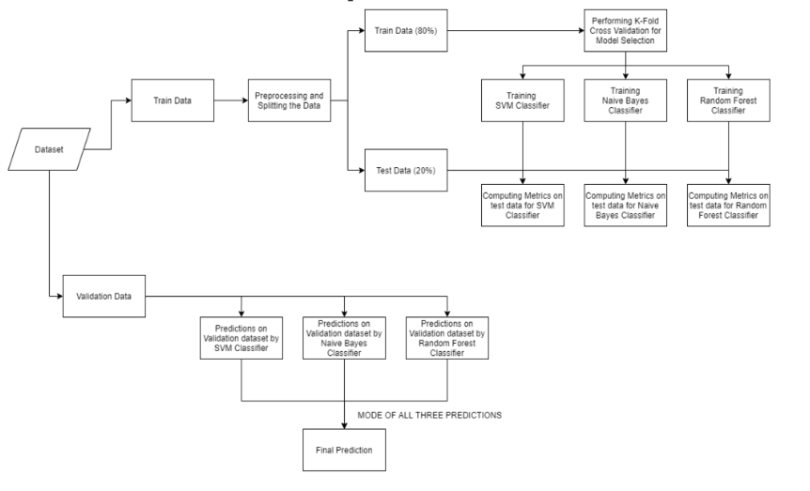

Fig1.Workflow for the implementation:

1.4 K-Nearest Neighbour (KNN)
A machine learning method built on the supervised learning model is known as the K-Nearest Neighbour (KNN) algorithm. In order for the K-NN algorithm to function, it must be assumed that similar entities exist nearby. Therefore, to forecast the values of the new data points, the K-NN algorithm uses feature similarity between the new data points and the points in the training set (available cases). The K-NN algorithm essentially values the most recent data point according to how much it matches the points in the training set. Although it can be used for classification and regression issues, the K-NN technique is most frequently utilised for classification issues..
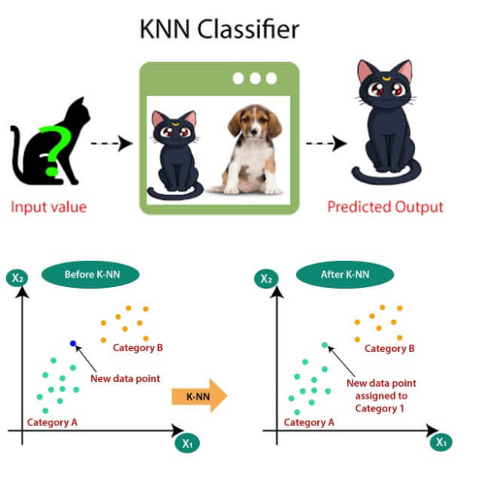
Fig1.Knn classifier
1.5 Navie bayes:
It's time to apply a simplistic premise to the Bayes theorem: the independence of the features. We have now divided the evidence into its individual components.
Therefore,
P(A,B) = P(A)P(B)
Thus, we arrive at the conclusion:

which can be said to be:

which can be expressed as:
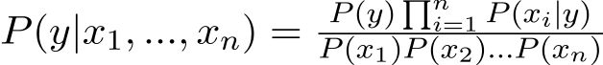

Now that the denominator is fixed for a particular input, we can eliminate that phrase:

We must now develop a classifier model. To do this, we calculate the likelihood of the given set of inputs for each potential value of the class variable y and choose the result with the highest probability. This can be mathematically stated as:

Finally, the work of calculating P(y) and P(xi | y) remains.
Remember that
probability.
The assumptions that different naive Bayes classifiers make about the distribution of P(xi | y) are what distinguish them from one another.
Let's attempt to manually apply the aforementioned formula to our weather collection. We must perform some precomputations on our dataset to achieve this.
For each xi in X and each yj in Y, we must determine P(xi | yj). The tables below show how these computations were made:
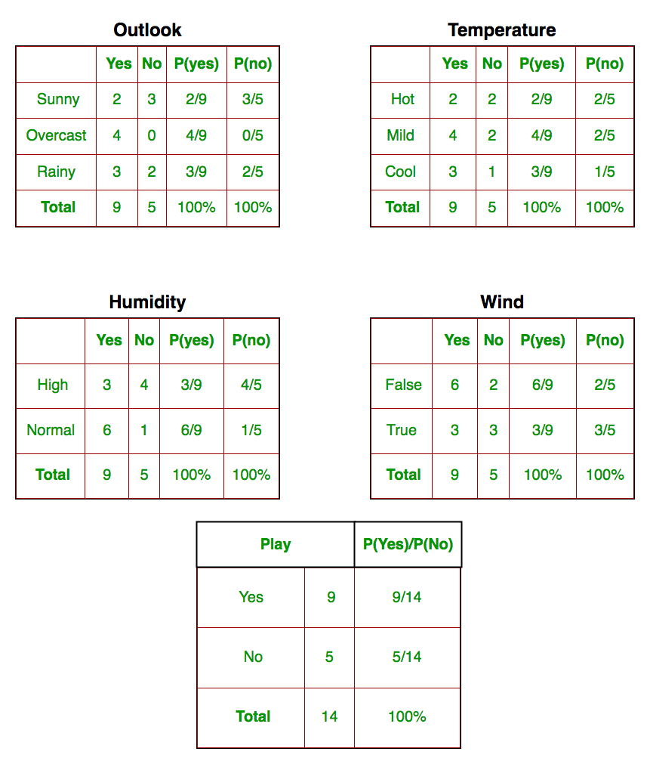
Fig1.navie bayes probability classifier
Therefore, in the tables 1-4, we manually calculated P(xi | yj) for each xi in X and yj in Y, as shown in the above picture. For instance, P(temp. = cool | play golf = Yes) = 3/9 is the probability of playing golf given that the temperature is cool.

1.6 Support vector machine:
The best way to comprehend Support Vector Machines' fundamentals and how they operate is with a straightforward example.
Imagine that our data contains two features—x and y—and that we have two tags—red and blue. Given a pair of (x,y) coordinates, we want a classifier that can determine if an object is red or blue. We use a plane to see our already-labeled training data.
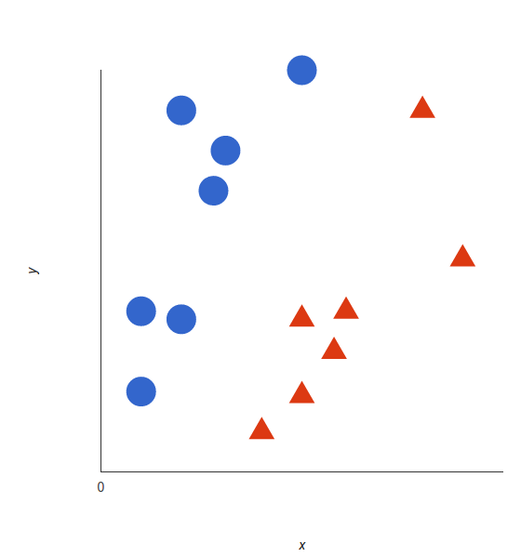fig1.svm classifier
These data points are sent into a support vector machine, which produces the hyperplane—which is just a line in two dimensions—that best separates the tags. The decision boundary is represented by this line; everything falling on one side of it will be classified as blue, and anything falling on the other as red.
What is the best hyperplane, though? It is the one that optimize the margins from both tags according to SVM. Or, to put it another way, the hyperplane (remember, it's a line in this case) with the biggest distance from the nearest element of each tag.
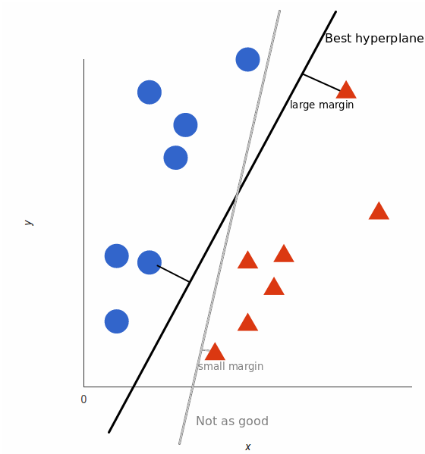
Fig 2 hyperplane

To see how this ideal hyperplane is discovered, watch this video instruction.

Nonlinear data
This example was simple because red and blue could easily be separated using a straight line because the data was obviously linearly separable. Unfortunately, things are rarely that easy. Look at this scenario:
It is quite obvious that the decision boundary is not linear (a single straight line that separates both tags). However, the vectors appear to be easily separable because of how clearly they are divided.
Therefore, this is what we'll do: we'll introduce a third dimension. We only had x and y up until this point. We introduce a new z-dimension and decree that its computation follow a particular path that is practical for us: You'll note that the equation for a circle is z = x2 + y2:
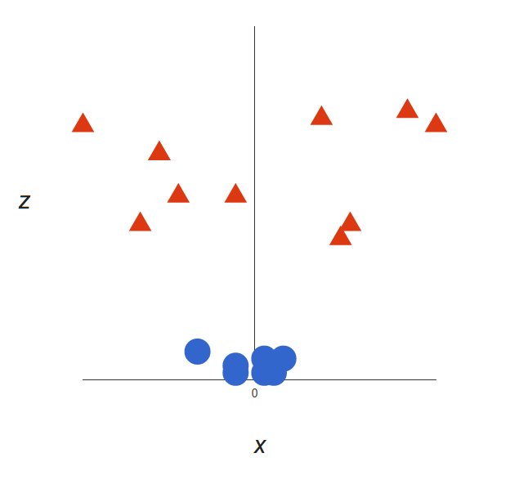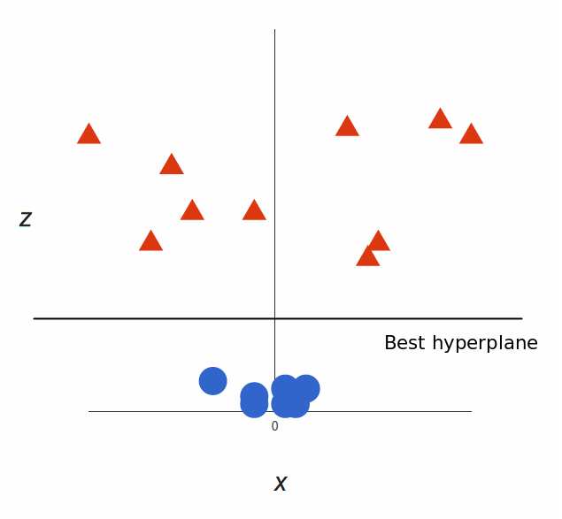

Fig3.SVM linear data
I love that! The hyperplane is a plane that is perpendicular to the x axis at a particular z (let's say z = 1) because we are now in three dimensions.
The final step is to map it back to two dimensions.
The final step is to map it back to two dimensions:
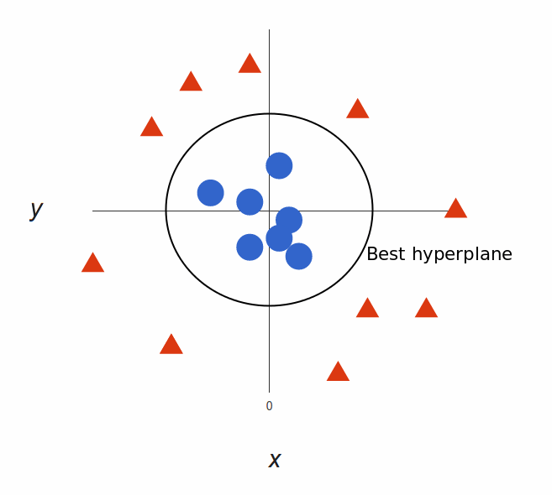

Fig4.SVM Nonlinear data

1.7 Decision Tree:
the most effective and well-liked classification and forecasting tool. A decision tree is a type of tree structure that resembles a flowchart, where each internal node represents a test on an attribute, each branch a test result, and each leaf node (terminal node) a class label
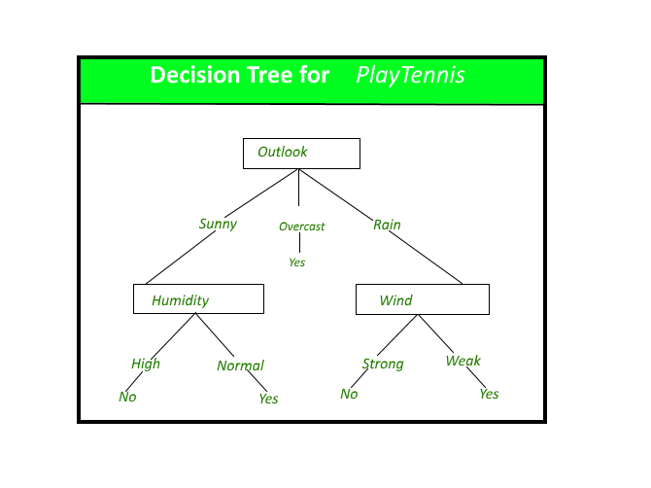
Fig decision tree for play tennis
Construction of Decision Tree:
By dividing the source set into subgroups based on an attribute value test, a tree can be "trained". It is known as recursive partitioning to repeat this operation on each derived subset. When the split no longer improves the predictions or when the subset at a node has the same value for the target variable, the recursion is finished. Decision tree classifier building is ideal for exploratory knowledge discovery because it doesn't require parameter configuration or domain understanding. High-dimensional data can be handled via decision trees. Decision tree classifiers are often accurate. A popular inductive method for learning classification information is decision tree induction.
Decision Tree Representation:
Decision trees categorise instances by arranging them in a tree from the root to a leaf node, which gives the instance's categorization. As seen in the above diagram, to classify an instance, one tests the attribute given by the root node of the tree before continuing down the branch of the tree that corresponds to the attribute's value. The subtree rooted at the new node is then subjected to the same procedure once more.
The decision tree in the preceding diagram categorises each morning according to whether it is appropriate for playing tennis and then returns the classification associated with each individual leaf (in this case Yes or No).
For instance, in this case
(Outlook = Sunny, Temperature = Hot, Humidity = High, Wind = Strong )
would be sorted through this decision tree's leftmost branch and categorised as a bad instance.
To put it another way, the decision tree is a disjunction of conjunctions of constraints on the attribute values of instances.
(Outlook = Sunny ^ Humidity = Normal) v (Outlook = Overcast) v (Outlook = Rain ^ Wind = Weak)

Gini Index:
The Gini Index is a number that measures how accurately a divide is between the groups that are categorised. A score between 0 and 1, where 1 represents a randomly distributed distribution of the elements within classes, is evaluated using the Gini index. In this situation, we wish to have a low Gini index score. The assessment statistic we will use to assess our decision tree model is the Gini Index..

Chapter 2

LITERATURE SURVEY

LITERATURE SURVEY

IoT was the subject of a thorough research that included relationships and restrictions. IoT's fundamental objective is to make Internet-based communications and the sending and receiving of information conventionally available when used with electronic sensor devices.

One study found that there were 28.4 billion IoT users in 2017 and that number will increase to 50.1 billion by 2020.
Scientific charity claims that IoT offers a variety of services. Continuity of contact is provided through "Wi-Fi, mobile phone, NFC, GPS, etc." Contrary to the creation of software, the primary goal of the Internet of Things is to include organisations and automation. The most commonly recycled sensors with accelerometers are embedded in compression-embedding systems like "MCUS, MPUs" at the beginning of the programmed.
IoT was the subject of a thorough research that included relationships and restrictions. IoT's fundamental objective is to make Internet-based communications and the sending and receiving of information conventionally available when used with electronic sensor devices.

One study found that there were 28.4 billion IoT users in 2017 and that number will increase to 50.1 billion by 2020.
Scientific charity claims that IoT offers a variety of services. Continuity of contact is provided through "Wi-Fi, mobile phone, NFC, GPS, etc." Contrary to the creation of software, the primary goal of the Internet of Things is to include organisations and automation. The most commonly recycled sensors with accelerometers are embedded in compression-embedding systems like "MCUS, MPUs" at the beginning of the programmed.

Chapter 3

SOFTWARE AND HARDWARE REQUIREMENTS

SOFTWARE AND HARDWARE REQUIREMENTS
Hardware
- esp32 board
- max30102 sensor
- jumper wires (generic)
- arduino USB 2.0 Cable

Datast
Health
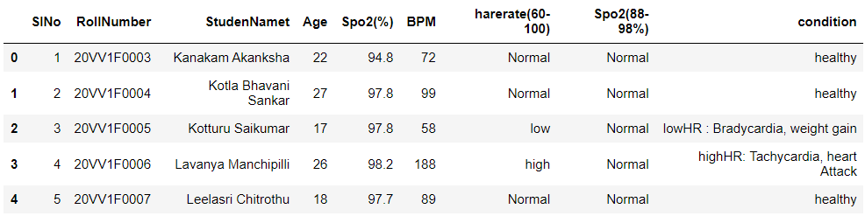

Software
- 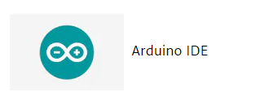 https://www.arduino.cc/en/software

-  https://thingspeak.com/login
-  https://www.anaconda.com

Hardware:
esp32 board & other connections
Processors:
  - Tensilica Xtensa 32-bit LX6 microprocessor as the primary CPU. 2 or 1 cores (depending on variation)
  - With the exception of the single-core ESP32-S0WD, all ESP32 family processors are dual-core.
  - Frequency of the clock: up to 240 MHz
  - Performance: 600 DMIPS or higher
  - Ultra low power co-processor: enables level thresholds, processing, and ADC conversions to be performed when in deep sleep.
  - cellular connections
  - Wi-Fi 802.11 b/g/n/e/i (2.4 GHz, 150 Mbit/s)
  - Bluetooth version 4.2 BR/EDR and Bluetooth LE (BLE)
Memory:
  - Innate memory
  - ROM: 448 KiB
  - For booting and fundamental operations.
  - SRAM: 520 KiB
  - For information and guidance.
  - 8 KiB RTC quick SRAM
  - For data storage and the primary CPU when the RTC wakes up from deep sleep.
  - Slow RTC SRAM: 8 KiB
  - For accessing the co-processor while in deep sleep mode.

max30102 sensor:
A digital pulse oximeter and heart rate sensor is a piece of technology that measures the difference between blood that contains oxygen and blood that doesn't. This device can test blood oxygen levels in addition to heart rate. In order to learn more about how this sensor functions, we will interface the well-known MAX30102 pulse oximeter and heart rate sensor with Arduino in this post. So let's get started without further ado.
Pulse oximeter and heart rate sensor MAX30102
The MAX30102 is a very flexible sensor that, in addition to measuring blood oxygen levels and heart rate, can also monitor body temperature. Two LEDs are present on this sensor, which was created by Analog Devices..
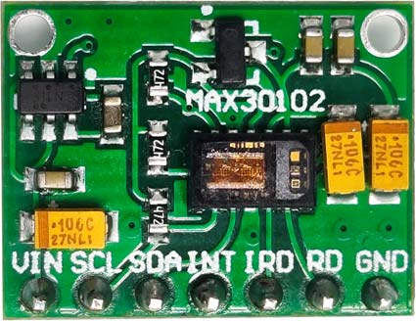
Fig 3.1 max30102 sensor
The main concept is to shine one LED at a time and measure how much light is reflected back to the sensor. You can calculate the heart rate and blood oxygen saturation from the reflection. This is a very brief explanation of how this sensor operates; a longer explanation will be provided later in the piece. But for the time being, let's examine further sensor settings.
Pinout for the MAX30102 Pulse Oximeter and Heart Rate Sensor
This module with the MAX30102 Digital Pulse Oximeter and Heart Rate Sensor have 7 pins total: VCC, SCL, SDA, INT, IRD, RD, and GND. Except for VCC and Ground, every pin on this sensor module is a digital one. The Pulse Oximeter and Heart Rate Sensor Pinout:
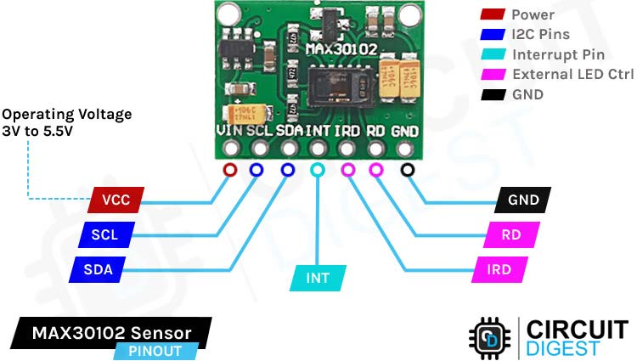
Fig 3.2: Pin out for the MAX30102 sensor
VCCis the pulse oximeter and heart rate sensor's power supply pin, which can be linked to the supply's 3.3V or 5V output.
SCL SCL The term "Serial Clock" This pin is periodically pulsed by the master device to create the clock signal needed for communication. Connect to the Arduino's A5 pin..
SDA means "Serial Data," and information is exchanged between two devices via this pin. This pin should be connected to the Arduino's A4 pin.
INTThe IC's Interrupt pin is labelled INT. This IC may be set up to produce an interrupt after every pulse. This pin's open drain nature causes it to be pulled high using an internal resistor. This pin becomes low during an interrupt and remains low until the interrupt is cleared.
IRD The IR LED of the Module is attached to this pin. Using this module.
RD The sole distinction between this pin and the IRD pin is that a RED LED is attached to it. If you don't want to drive the LED yourself, leave it alone.
GND The Arduino's ground pin should be linked to the pulse oximeter and heart rate sensor module's ground pin, or GND.
Operating Power of MAX30102 Pulse Oximeter and Heart Rate Sensor
The module's operational voltage ranges from 3.3 to 5 volts, with a maximum current draw of 600 uA. However, the MAX30102 IC on the module board needs two separate supply voltages for steady operation, which is why there are two linear low dropout regulators on the module board. The first is for 3.3V, while the second is for 1.8V. For a clearer understanding, go to the section on part marking. The power consumption of this module, which is less than 600 A while being measured by MAX30102, is one of its most intriguing qualities. And while it is in standby mode, it uses just 0.7 A.
This gadget can be utilised in battery-powered applications because to its low power consumption. Except than that, this.

Interrupts on MAX30102 Pulse Oximeter and Heart Rate Sensor:
The MAX30102 Sensor has 5 different sorts of interrupts, according to its datasheet. While the sensor is gathering data, these interrupts can be used to complete other activities in the microcontroller. These are displayed farther down.
Power Ready: When the supply voltage VDD changes from below the UVLO voltage to above the UVLO voltage during power-up or following a brownout condition, a power-ready interrupt is set off to indicate that the IC is switched on and prepared to receive data.
SPO2 Data Ready: In SpO2 mode, this interrupt fires following the collection of each data sample. One IR and one red data point make up a SpO2 data sample. When the FIFO data register is read, this bit is automatically cleared.
Ready Heart Rate Data: This interrupt is triggered following the collection of each data sample in the heart rate or SPO2 modes. One IR data point is all that makes up a heart rate data sample. When the FIFO data register is read, this bit is automatically cleared
Temperature Ready: This interrupt is started when the internal die temperature conversion is complete..
FIFO Almost Full: This interrupt is set off in the SpO2 and heart-rate modes when the number of unwritten spaces in the FIFO equals one less than the sum of the read and write pointers. The FIFO fills up and lost future data occurs if it is not read within the subsequent conversion time.
The inbuilt resistor pulls HIGH the INT line because it is an open drain. The INT pin goes low when an interrupt happens and remains low until the interrupt is cleared.

MAX30102 Pulse Oximeter and Heart Rate Sensor Works
The max30102 sensor is made up of a Red LED, an IR LED, and a photodetector, as we've already described. The RED LED's wavelength is 660 nanometers, while the IR LED's wavelength is 880 nanometers.

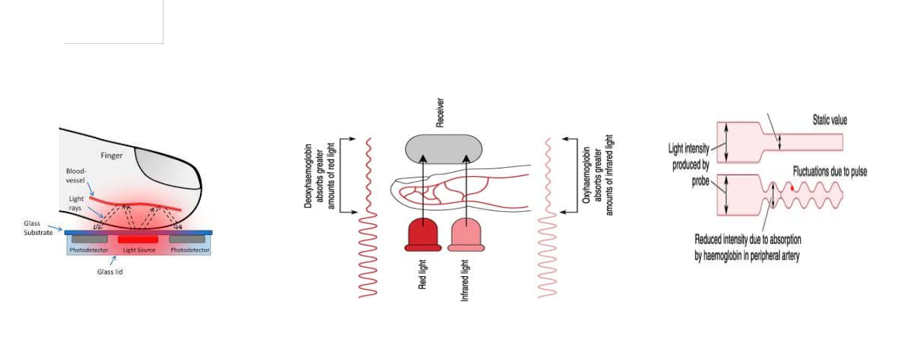
Fig 3.3: collect the data from sensor:

The MAX30102 Sensor uses a photodetector to detect the reflection as well as beam light through the skin. Photoplethysmogram is the name of this technique for light-based pulse detection. One aspect of the sensor's operation is the measurement of heart rate, and the other is the monitoring of blood oxygen levels.
The oxygen in haemoglobin has the unique ability to absorb infrared light. The colour of the blood increases with haemoglobin concentration. Therefore, it can absorb more IR radiation. The amount of light reflected fluctuates as the blood flows through the veins in the finger, producing an oscillating waveform. We can get the heartbeat reading by measuring this wave. The idea behind blood oxygen level measuring is.

MAX30102 Pulse Oximeter and Heart Rate Sensor Module – Parts
The designer designed this sensor so that anyone with a basic understanding of electronics can use it. As a result, it only needs a small number of easily accessible components for reliable functioning, including three resistors, two filter capacitors, and two LDOs. The sensor's parts marking is displayed below.
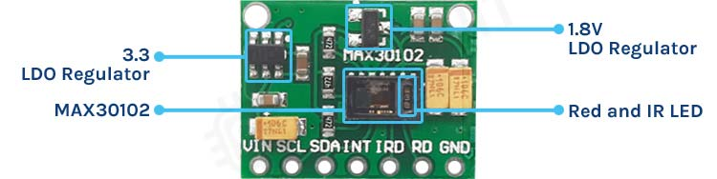

Fig 3.4. MAX30102 Sensor Module – Parts

There are two power pins, VCC and GND, among the sensor's total of seven pins. The other five pins are used for 3.3V tolerant data and clock signals. The board features several filter capacitors, as you can see. The board has three resistors for the SCL, SDA, and INT lines, as well as a few filter capacitors for two LDOs, as you can see in the figure above. But the module has a flaw, which we'll talk about in a later section of the essay.
MAX30102 Pulse Oximeter and Heart Rate Sensor Module Circuit Diagram
Below is a schematic for the MAX30102 Pulse Oximeter and Heart Rate Sensor Module. The actual schematic only calls for a small number of components.
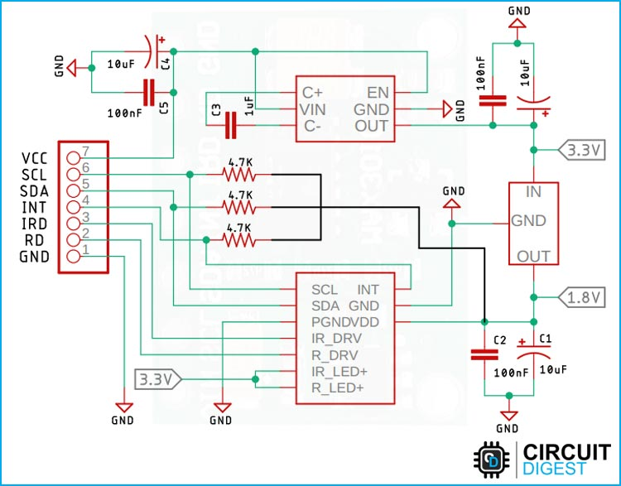
Fig 3.5:MAX30102 Sensor Module Circuit Diagram

Our MAX30102 is shown in the schematic along with three pull-up resistors. Beyond that, we have two LDOs, the first of which operates at 3.3V and the second at 1.8V. The sensor IC must be powered by a 1.8V supply, and the LEDs inside the IC must be powered by a 3.3V supply. In addition, several filter capacitors and some decoupling capacitors are needed for the LDOs to operate steadily. The MAX30102 Sensor module is made up of each of these parts.
Please take note that there is a significant defect in the schematic and the module, which is why we made a section of the schematic with black wires. In the troubleshooting part, we went into great detail about the issues and their solutions.

MAX30102 Pulse Oximeter and Heart Rate Sensor not Working:
Two issues were discovered while working with the sensor module, the first of which is noted in the schematic section. As you can see, the three pullup resistors on the module board are linked to 1.8V logic level rather than 3.3V logic level in the schematic. As a result, when we try to connect it to an Arduino, it does not function since the logic level is too low. You must disconnect the three pullup resistors from the board and connect external resistors to fix this problem. You can see how we did that in the part on the connection diagram
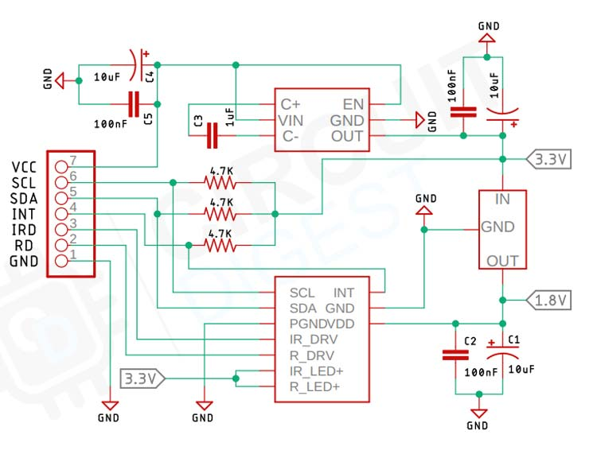

Fig 3.6: MAX30102 Sensor not Working:

You can use the above image as a reference without any problems because we have corrected the schematic as needed. Additionally, the module with and without resistors is shown in the image below.

Arduino USB 2.0 Cable:

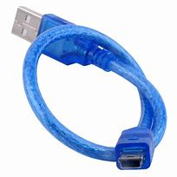
Fig 3.6Arduino USB 2.0 Cable
Use it to connect any board to your computer's USB female A port, including Arduino Uno, Arduino Mega 2560, Arduino 101, and more.
The length of the cable is about 178 cm. Due to the rotation of our stock, cable colour and form may differ slightly from image.
To learn more about USB cables and standards, visit pinouts.ru's USB cable pinouts referral page.
Standard USB 2.0 cable, type A/B USB cable.
Typical Application :
Jumper wires (generic):
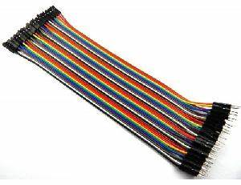
Fig 3.8 Jumper wires (generic)
An electrical wire, or group of them in a cable, with a connector or pin at each end (or sometimes without them - simply "tinned") is known as a jump wire (also known as a jumper, jumper wire, jumper cable, DuPont wire or cable), and it is typically used to connect the parts of a breadboard or other prototype or test circuit, internally or with other equipment or components, without soldering.
Individual jump wires are attached by slipping their "end connectors" into slots made available on a breadboard, a circuit board's header connection, or a piece of test equipment.
Types:
Jumper wires come in a variety of varieties. While some have separate connectors, others have the same kind of electrical connector on both ends. Typical connectors include:

- Solid tips – are utilised to connect on or with a female header connector or breadboard. Increased mounting density of components and jump wires is possible on a breadboard without worrying about short circuits because of how the pieces are arranged and how simple they are to install. To distinguish the various functioning signals, the jump wires are different sizes and colours.
- Crocodile clips – are employed, among other things, to bridge prototype sensors, buttons, and other parts with equipment or parts with arbitrary connectors, wires, screw terminals, etc.
- Banana connectors –In test equipment for DC and low-frequency AC signals, are frequently used.
- Registered jack (RJnn) –are frequently utilised in computer networking and telephone (RJ11) (RJ45).
- RCA connectors – are frequently used for low-frequency applications that call for a shielded cable, such as audio and low-resolution composite video signals.
- RF connectors – are employed to transmit radio frequency signals between test devices, antennas, and circuits.
- RF jumper cables - Jumper cables are corrugated wires that are thinner, more flexible, and used to connect antennas and other hardware to network cabling. Jumpers are also utilised in base stations to link radio equipment and antennas. The diameter of 1/2" jumper cables is typically the most flexible.

Breadboard(generic):

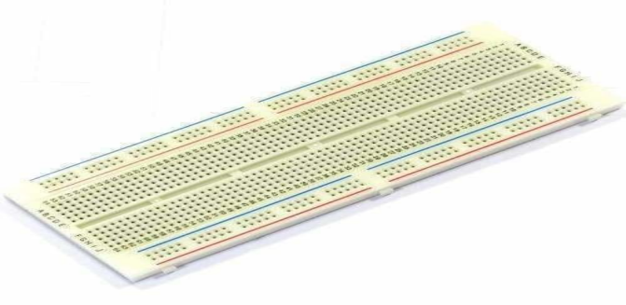
Fig 3.9 Breadboard(generic):
A breadboard, often known as a protoboard, is a construction platform for electronics experimentation. The term originally referred to a bread board, which is a polished piece of wood used for slicing bread. [1] The solderless breadboard, also known as a plugboard or a terminal array board, was introduced in the 1970s, and today the name "breadboard" is frequently used to describe these.

The solderless breadboard is reusable because soldering is not necessary. This makes it simple to utilise for developing temporary prototypes and conducting circuit design experiments. Solderless breadboards are therefore common among students and in technological education. Earlier breadboard models lacked this characteristic. a strip board (Veroboard) or other prototyping printed circuit board that is used to create soldered prototypes that are semi-permanent,
Modern breadboards have less dependable connections that are vulnerable to jostling and physical degradation, high parasitic capacitance, and relatively high resistance as compared to more permanent circuit connection techniques. About 10 MHz is the upper limit for signalling, and even at frequencies considerably below that, not everything functions well.

In the system on a chip (SoC) era, it is common practise to purchase a microcontroller (MCU) on a pre-assembled printed circuit board (PCB) that exposes an array of input/output (IO) pins in a header that can be plugged into a breadboard, and then prototype a circuit that takes advantage of one or more of the MCU's peripherals, such as general-purpose input/output (GPIO), UART/USART
The MCU's firmware is subsequently created in order to test, debug, and communicate with the circuit prototype. The PCB of the SoC becomes mainly the only place for high frequency operation. High speed interconnects like SPI and I2C can be debugged at a slower rate and then rewired to take advantage of full-speed functionality utilising a different circuit building technique. Most of these electrical interface possibilities are frequently provided by a single tiny SoC, which can be purchased in the American hobby market (and abroad) for a few dollars. This enables fairly complex breadboard projects to be produced at a minimal cost.

Bus and terminal strips:
Metal strips inside the breadboard are used to connect the pins on solderless breadboards. Two different types of areas, referred to as strips, make up the layout of a typical solderless breadboard. Electrical terminals are joined together to form strips.
Terminal strips:
- The primary areas, which house the majority of the electronic components
- A notch that runs parallel to the long side is often found in the centre of a terminal strip on a breadboard.
- The notch serves as a guide for the terminal strip's centerline and offers DIP ICs that are straddling it a small amount of airflow (cooling).
- The clips on the right and left sides of the notch are each electrically connected in a row of five clips (i.e., beneath five holes) on each side of the notch.
- A, B, C, D, and E are frequently used to denote the five columns on the left of the notch, whereas F, G, H, I, and J are used to denote the five columns on the right.
- When a "skinny" dual in-line pin package (DIP) integrated circuit is plugged into a breadboard, the pins of one side should go into column E and the pins of the other side should go into column F on the other side of the notch. Examples of typical DIP-14 or DIP-16 packages are those with a 0.3-inch (7.6 mm) separation between the pin rows.
- The breadboard design allows for a maximum of as many rows as there are rows. In its micro, half, and full designs, the majority of breadboards can fit 17, 30, or 64 rows
- Breadboard without soldering that has dual bus strips on both sides
Bus strips:
to supply the electronic components with power.
- Typically, a bus strip has two columns:
1. one for ground
2. one for a supply voltage.
- On each long side, some breadboards, however, only offer a single-column power distribution bus strip. Typically, the ground row is indicated in blue or black, whereas the row designed for a supply voltage is marked in red.
- Others only connect groups of, say, 25 consecutive terminals in a column, but some manufacturers connect every terminal in a column.
- A circuit designer has a little more control over crosstalk (inductively coupled noise) on the power supply bus using the latter configuration. Gaps in the colour coding on a bus strip are frequently used to identify the groupings.
- In between terminal strips or down one or both sides of a terminal strip, bus strips are common. Additional bus strips are frequently seen on the top of big breadboards..
For instance, some GPIO to breadboard adapters for the Raspberry Pi employ offset aligned power pins, which prevents them from fitting on breadboards with aligned power bus rows. Since there are no formal standards, users must pay close attention to whether a particular model of breadboard and a given accessory are compatible. The alignment that accessory and breadboard vendors employ isn't necessarily specified in their specifications. A close-up shot of the pin/hole configuration can be used to assess compatibility.

Arduino ide:
https://www.arduino.cc/en/software
Jupyter notebook
Thingspeak cloud

step1:
Browse the link to find the most recent version and system requirements.
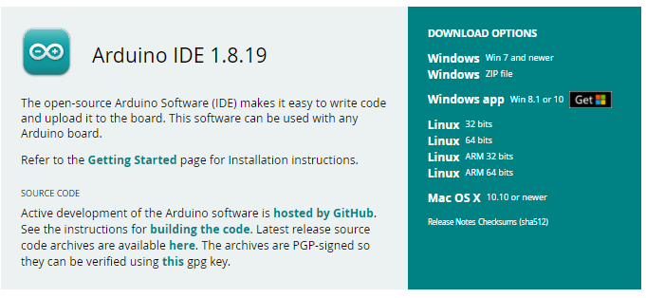
Fig 3.10: arduino IDE 1.8.19
Choose the appropriate link for your system version under Windows or Linux 32/64 bit.
step 2:
simply click the download button
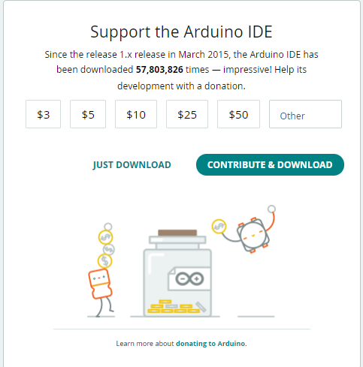
step 3:
Following installation of the arduino file after clicking on the open file button after downloading, we can see the arduino icon in our display looking like this


Place the sensor:
- You're going to start by placing the sensor on the breadboard.
- The blue portion of the sensor should be towards you if you position the breadboard according to how it was designed.
Connect everything:
- The sensor's pins are labelled S, signal, voltage, and ground, respectively.
- The middle pin stands for signal. On the Arduino, the signal pin is connected to header A0.
- The middle pin connects to 5 volts, and the bottom pin to ground (GND).
- Our black cable is ground, our red wire is power, and our yellow cable is our analogue cable.
Thingspeak:
With the help of the IoT analytics tool ThingSpeak, you can gather, visualise, and examine real-time data streams online. Data sent by your devices to ThingSpeak is instantly visualised by ThingSpeak. You can undertake online analysis and analyse data as it comes in with the option to run MATLAB code in ThingSpeak. For IoT systems that need analytics, ThingSpeak is frequently used for prototyping and proof-of-concept systems.

Using a Rest API or MQTT, you may submit data directly to ThingSpeak from any internet-connected device. Additionally, The Things Network, Senet, the Libelium Meshlium gateway, and Particle.io's cloud-to-cloud integrations make it possible for sensor data to reach ThingSpeak across LoRaWAN and 4G/3G cellular connections.

Without deploying web servers, you may store and analyse data in the cloud with ThingSpeak..

visit the website below
https://thingspeak.com/login?skipSSOCheck=true
Sign up
After registering enter the website

build a new channel

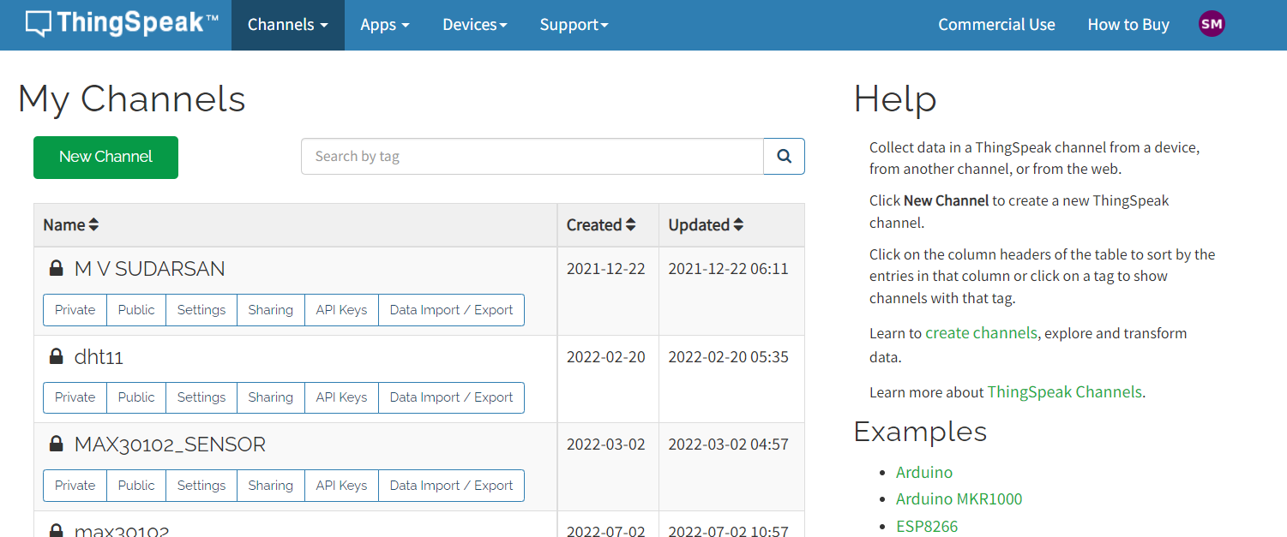

Fig 3.10:thingspeak channel

Chapter 4

METHODOLOGY

METHODOLOGY

Case study:

Arduino IDE and ESP32 Boards Add-on
ESP32 will be programmed using the Arduino IDE. Therefore, the ESP32 add-on must be installed. If you haven't already, go on to the next tutorial:
Installing ESP32 Board in Arduino IDE (Windows, Mac OS X, Linux)
board and sensor interface
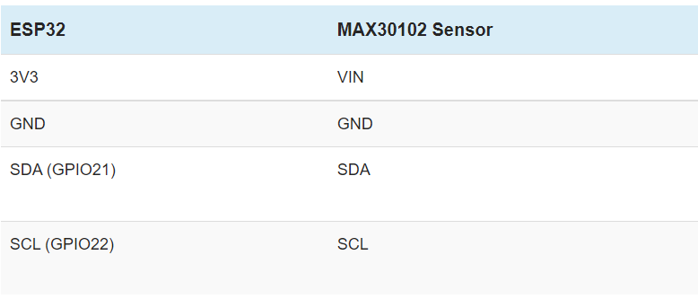
Fig 4.1:board and sensor interface
connect the board to thingspeak:
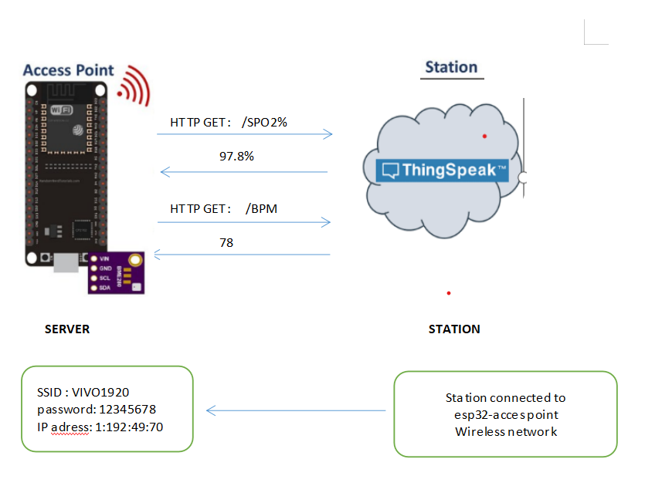
Fi4.2: connect the board to thingspeak:

the max30102 sensor and the esp32 board are connected in a black schematic
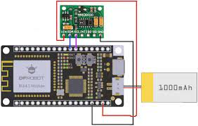
Fig 4.3 max30102 sensor and the esp32 board are connected in a black schematic
Run this code on an Arduino Uno board:

Data send to thingspeak&jupyter
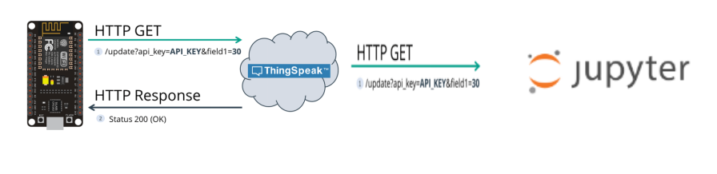
Fig 4.4:Data send to thingspeak&jupyter

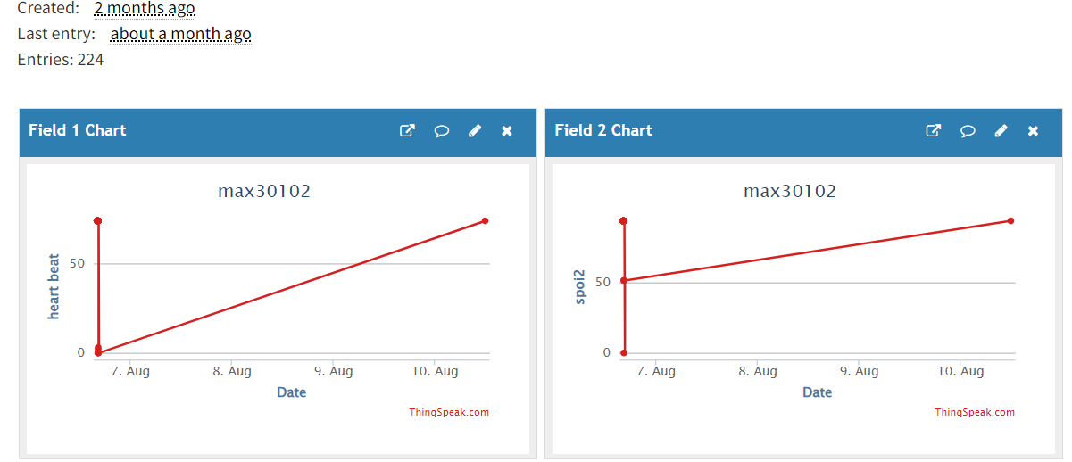

Protocol :
I2c protocol:
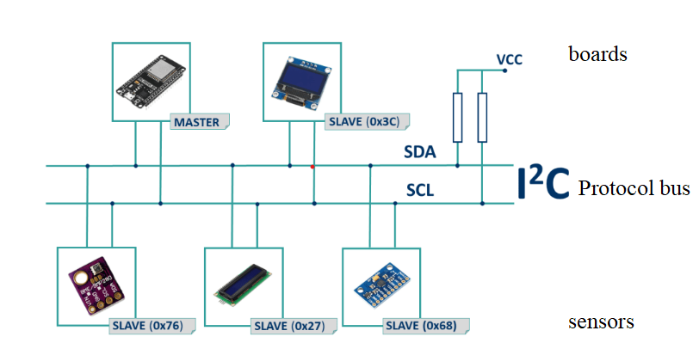
Fig 4.5: i2c protocol
IP Protocol :
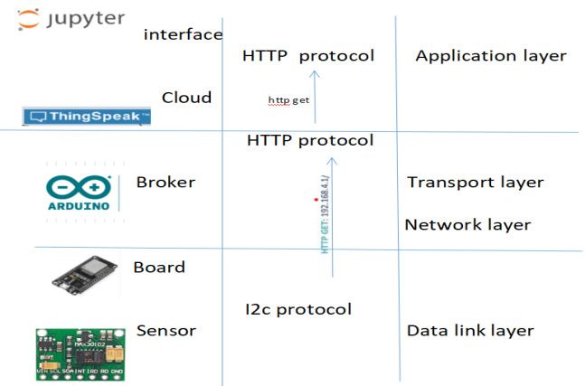
Fig 4.6 ip protocol
Chapter 5

PROBLEM STATEMENT

PROBLEM STATEMENT
Without doctors, the patient is unable to consult them, which could lead to an emergency situation. Due to the increase in health issues in the modern world, personal health monitoring is thought to be of utmost importance. The general health is being severely harmed by the increasingly stressed way of life. Doctor expenses have skyrocketed due to longer hospital wait times and an increase in patients, which is particularly hurting individuals who cannot afford the fees or who do not have serious illnesses but discover they have only after paying a substantial fee to the doctor.
Because the patient cannot consult the doctors in their absence, an emergency scenario can potentially arise. Each person's personal health monitoring is regarded as being of utmost importance due to the rise in health issues in today's society. Public health is being severely harmed by the rising stress in society. With longer wait times at hospitals and more patients, doctor fees have skyrocketed, which is particularly hurting those patients who cannot afford the fee or who are not experiencing serious illnesses but discover they are only after paying a substantial fee to the doctor.

The most relevant IoT-related issues, difficulties, and trends are presented in this area.

- IoT effectively connects patients, medical facilities, doctors, and clinics to plan and coordinate diagnosis and care across numerous locations. Data confidentiality and protection are the main issues with healthcare systems during the pandemic since it crosses an unsecure system. The patient's care record, which is made up of sensitive information such as personal information, clinical conditions, diagnosis results, and related drugs. Hackers may alter health-related information, leading to misdiagnosis or inaccurate disease evaluation leading to ineffective treatment, raising the mortality rate. IoT devices that track medical data transmission are susceptible to security issues

- Due to the demands of each component, such as storage requirements, operating system requirements, and network design, privacy and security issues are discovered at the hardware level in terms of compliance with the patient's records.

- Due to the nature of the programmes utilised, there is an integration issue at the device level where certain devices support all programming languages while others only support a select few. In healthcare systems like COVID-19, IoT gadgets and biosensors continuously monitor key metrics. Thus, wearing sensors continuously can result in skin rashes and use considerably more power.

4.Cost analysis researchers should think about creating low-cost drug solution experiments enabled by IoT. Health-care facilities and clinics must deal with a huge number of patients during the epidemic, and a significant number of medical professionals must do a variety of tasks. In these situations, it is essential to ensure proper data protection that patients and staff can be identified accurately. To ensure that all patients may access medical facilities via mobile devices like smartphones, IoT on a smaller scale requires that handheld devices contain sensors for data collecting. It also requires that centralised servers process patient requests.

5. The vast heterogeneity of systems, devices, services, and platforms operating and potentially exploited for new or enhanced applications is a serious issue with adopting IoT for patient monitoring. As a result, heterogeneity is also a significant concern.

Chapter 6

IMPLEMENTATION

IMPLEMENTATION
Import libraries:
import nimby and pandas
Pandas:
Python's Pandas package is used to manipulate data sets.
It offers tools for data exploration, cleaning, analysis, and manipulation.
With the aid of Pandas, we can examine large data sets and draw conclusions based on statistical principles.

Numpy:
The Python package NumPy is used to manipulate arrays.
Additionally, it has matrices, fourier transform, and functions for working in the area of linear algebra.
In the year 2005, Travis Oliphant developed NumPy. You can use it for free because it is an open source project.

Code posting the data to thingspeak

#include <WiFi.h>
#include <HTTPClient.h>

const char* ssid = "vivo1920";
const char* password = "12345678";

//Your Domain name with URL path or IP address with path
String serverName = "https://api.thingspeak.com/update?api_key=4510U37MWIDIFOVY&field1=74&field2=93";
// the following variables are unsigned longs because the time, measured in
// milliseconds, will quickly become a bigger number than can be stored in an int.
unsigned long lastTime = 0;
// Timer set to 10 minutes (600000)
//unsigned long timerDelay = 600000;
// Set timer to 5 seconds (5000)
unsigned long timerDelay = 5000;

void setup() {
Serial.begin(115200);

// WiFi.begin("vivo1920", "12345678");
WiFi.begin(ssid, password);
Serial.println("Connecting");
while(WiFi.status() != WL_CONNECTED) {
delay(500);
Serial.print(".");
}
Serial.println("");
Serial.print("Connected to WiFi network with IP Address: ");
Serial.println(WiFi.localIP());

Serial.println("Timer set to 5 seconds (timerDelay variable), it will take 5 seconds before publishing the first reading.");
}

void loop() {
//Send an HTTP POST request every 10 minutes
if ((millis() - lastTime) > timerDelay) {
//Check WiFi connection status
if(WiFi.status()== WL_CONNECTED){
HTTPClient http;

String serverPath = serverName ;

// Your Domain name with URL path or IP address with path
http.begin(serverPath.c_str());

// Send HTTP GET request
int httpResponseCode = http.GET();

if (httpResponseCode>0) {
Serial.print("HTTP Response code: ");
Serial.println(httpResponseCode);
String payload = http.getString();
Serial.println(payload);
delay(10000);
}
else {
Serial.print("Error code: ");
Serial.println(httpResponseCode);
}
// Free resources
http.end();
}
else {
Serial.println("WiFi Disconnected");
}
lastTime = millis();
}
}
Testing:
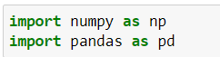
Load dataset:
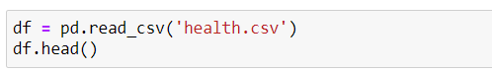
Output:

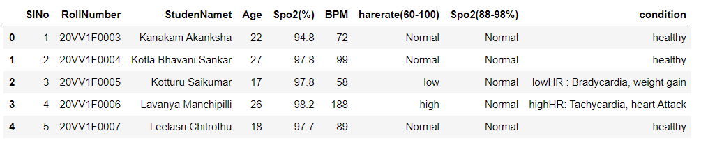
Preprocessing:
- null values :
The number of null values is counted using the Isnull() method.
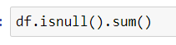

- Label encoder:
The data farmat is converted to int farmat by the label encoder
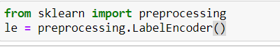
- Test train split
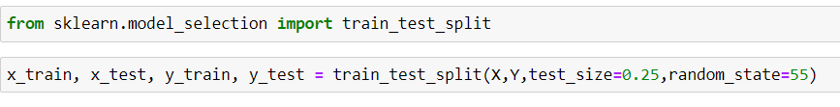
Decide on a test dataset size of 25% (.25) and a training dataset size of 75% for the dataset.
Apply the models :

KNN classifier

In [28]:
knn = KNeighborsClassifier(n_neighbors=3)

In [29]:
knn.fit(x_train, y_train)
Out[29]:
KNeighborsClassifier(n_neighbors=3)

In [30]:
y_predict1 = knn.predict(x_test)
y_predict1

In [31]:
x_test.head(2)

Out[31]:
 | Spo2(%) | BPM
439 | 94.8 | 72
294 | 97.8 | 99

Testing:

knn.predict([[a,b]])
Out[32]:
array(['highHR: Tachycardia, heart Attack'], dtype=object)

naivy_bayes:
- wp
In [33]:
from sklearn.naive_bayes import GaussianNB
gnb = GaussianNB()

In [34]:
gnb.fit(x_train,y_train)
Out[34]:
GaussianNB()

In [35]:
y_pred = gnb.fit(x_train, y_train).predict(x_test)
y_pred

In [36]:
print("Number of mislabeled points out of a total %d points : %d"
... % (x_test.shape[0], (y_test != y_pred).sum()))
Number of mislabeled points out of a total 238 points : 13

In [37]:
gnb.predict([[a,b]])
Out[37]:
array(['healthy'], dtype='<U97')

support vector machine

In [38]:
from sklearn.svm import SVC

In [39]:
sv1 = SVC(kernel='linear')

In [40]:
sv1.fit(X, Y)
Out[40]:
SVC(kernel='linear')

In [41]:
y_predict1 = sv1.predict(X)
y_predict1

In [42]:
sv1.predict([[a,b]])
Out[42]:
array(['highHR: Tachycardia, heart Attack'], dtype=object)

Decision Tree
- RP
In [43]:
from sklearn.metrics import confusion_matrix, accuracy_score
​

In [44]:
from sklearn.tree import DecisionTreeClassifier
dcl1 = DecisionTreeClassifier(criterion='gini',
max_depth = 2)

In [45]:
dcl1.fit(x_train, y_train)
​
Out[45]:
DecisionTreeClassifier(max_depth=2)

In [46]:
confusion_matrix(Y, y_predict1)
Out[46]:
array([[ 58, 0, 0, 0, 0, 0, 0, 0],
[ 0, 58, 0, 0, 0, 0, 0, 0],
[ 0, 0, 585, 0, 0, 0, 0, 0],
[ 0, 0, 0, 30, 0, 0, 0, 0],
[ 0, 0, 0, 0, 43, 0, 0, 0],
[ 0, 0, 0, 0, 0, 59, 0, 0],
[ 0, 0, 0, 0, 0, 0, 102, 0],
[ 0, 0, 0, 0, 0, 0, 15, 0]], dtype=int64)

In [47]:
accuracy_score(Y, y_predict1)
Out[47]:
0.9842105263157894

In [48]:
dcl1.predict([[a,b]])
Out[48]:
array(['danger : Bradycardia, weight gain, Anemia,Asthma,Emphysema,chronic obstructiv\ne pulmonary desiese'],
dtype=object)

Explonaory data analysis

In [49]:
from sklearn import tree
import matplotlib.pyplot as plt

In [50]:
tree.plot_tree(dcl1)
plt.show()
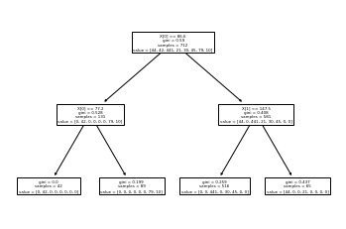

In [51]:
import matplotlib.pyplot as plt
import numpy as np
import seaborn as sns

In [52]:
X
Out[52]:
 | Spo2(%) | BPM
0 | 94.8 | 72
1 | 97.8 | 99
2 | 97.8 | 58
3 | 98.2 | 188
4 | 97.7 | 89
... | ... | ...
945 | 97.8 | 58
946 | 98.2 | 88
947 | 97.7 | 89
948 | 78.4 | 73
949 | 97.3 | 87
950 rows × 2 columns
In [53]:
x2=pd.DataFrame(X)
x2
Out[53]:
 | Spo2(%) | BPM
0 | 94.8 | 72
1 | 97.8 | 99
2 | 97.8 | 58
3 | 98.2 | 188
4 | 97.7 | 89
... | ... | ...
945 | 97.8 | 58
946 | 98.2 | 88
947 | 97.7 | 89
948 | 78.4 | 73
949 | 97.3 | 87
950 rows × 2 columns
In [54]:

l1=x2['Spo2(%)'].tolist()
l2=x2['BPM'].tolist()
X1=l1+l2
X1=pd.DataFrame(X1)
X1
Out[54]:
 | 0
0 | 94.8
1 | 97.8
2 | 97.8
3 | 98.2
4 | 97.7
... | ...
1895 | 58.0
1896 | 88.0
1897 | 89.0
1898 | 73.0
1899 | 87.0
1900 rows × 1 columns

In [55]:
plt.subplots(figsize=(4,6))
sns.countplot(Y, data=X1)
plt.xlabel("condition")
plt.title("health monitoring")
plt.show()
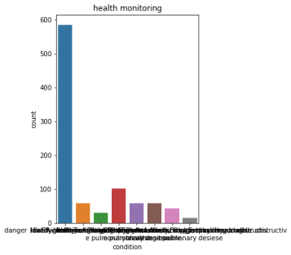
Chapter 7

RESULT AND ANALYSIS

RESULT AND ANALYSIS

Input formation:
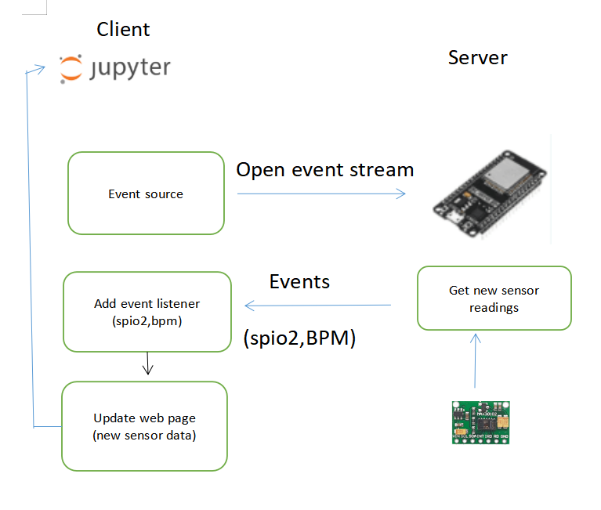
Fig : data transformation from sensor to notebook
Code for input:

In [10]:

df1=pd.read_csv('https://api.thingspeak.com/channels/1787697/fields/1.json?api_key=J16WJXLTTQ0EM9LE&results=2')
df1

Out[10]:
 | {"channel":{"id":1787697 | name:"max30102" | description:"health monitoring" | latitude:"0.0" | longitude:"0.0" | field1:"heart beat" | field2:"spoi2" | created_at:"2022-07-02T10:57:26Z" | updated_at:"2022-07-02T10:57:27Z" | last_entry_id:224} | feeds:[{"created_at":"2022-08-06T11:08:54Z" | entry_id:223 | field1:"0"} | {"created_at":"2022-08-10T06:30:34Z" | entry_id:224 | field1:"74"}]}

In [11]:
s=''
d=s.join(df1)
d
Out[11]:
'{"channel":{"id":1787697name:"max30102"description:"health monitoring"latitude:"0.0"longitude:"0.0"field1:"heart beat"field2:"spoi2"created_at:"2022-07-02T10:57:26Z"updated_at:"2022-07-02T10:57:27Z"last_entry_id:224}feeds:[{"created_at":"2022-08-06T11:08:54Z"entry_id:223field1:"0"}{"created_at":"2022-08-10T06:30:34Z"entry_id:224field1:"74"}]}'

In [12]:
x = d.split("{")
y=x[4]
y

Out[12]:
'"created_at":"2022-08-10T06:30:34Z"entry_id:224field1:"74"}]}'

In [13]:
sp_chars = [';', '"', "*",'[',']','{','}']
givenStr = y
givenStr = ''.join(i for i in givenStr if not i in sp_chars)
givenStr
Out[13]:
'created_at:2022-08-10T06:30:34Zentry_id:224field1:74'

In [14]:
m = givenStr.split(':')
a=m[len(m)-1]
f=m[len(m)-2]

In [15]:
string = ''.join((element for element in f if element.isdigit()))
string
Out[15]:
'2241'

In [16]:
b=string[:-1]

In [17]:
a=int(a)
b=int(b)
print(a,b)
74 224

Output:
dcl1.predict([[a,b]])

array(['danger : Bradycardia, weight gain, Anemia,Asthma,Emphysema,chronic obstructiv\ne pulmonary desiese'],
dtype=object)

Chapter 8

CONCLUSION AND FUTURE SCOPE

CONCLUSION AND FUTURE SCOPE

- IoT is regarded as one of the primary sources for gathering a significant amount of data. Researchers must be concerned with the storage, access, transit, and processing of the enormous amount of data they will produce with the vast amount of patient information that have been gathered.

- The ability to infer, measure, and gather patient data for COVID-19 is made possible via sensor networks. In order to be used in large-scale remote sensing applications, low-cost, low-power miniaturised devices have been created. Smartphones are equipped with a wide range of sensors, including cameras, GPS, accelerometers, and digital compass, enabling a variety of mobile applications with COVID-19. One of the primary issues in this situation is the timely processing of massive and streaming sensor data that is susceptible to energy and network limits and uncertainty.

- In order to promote interoperability and scale the cost of IoT facilities, research is still needed on the deployment of appropriate communication protocols like IPv6 for uniquely addressing the things, the setting of various IoT standards, and the assessment of risks and uncertainties. As a result, additional novel protocols will be required in the future.

- IoT applications use a variety of heterogeneous network technologies, and because continuous transmission of the data collected is necessary for patient monitoring, the overall bandwidth usage increases significantly. However, there is still room for improvement on how effectively access management can enable continuity and optimise bandwidth usage.

- To maintain the data and datasets' highest level of security and integrity, the COVID-19 patients' collected datasets should be saved and retained in convenient, secure locations. To select the appropriate data and datasets for each service, an intelligent system based on artificial intelligence approaches must be researched in the data warehouse.
- Many experts believe that the absence of standards is a significant barrier to adopting IoT. Interoperability in this situation is still difficult.
- Software and system designs must be specified, coded, and carried out in accordance with standards, such as the map-reduce framework and any other software frameworks that might speed up and simplify processing.
- For patients to easily use and learn from complicated outputs, visualisation is required. in order to compute the analysis of the patient's data as outputs or to use the visualization-based outputs of statistical analysis.
- IoT apps frequently transmit COVID-19 patient data from them and other things to a cloud; this operation quickly depletes the battery power of the gateway as well as the other things. As a result, a significant outstanding problem is energy efficiency in both data processing and transmission.
Chapter 9

REFERENCES

REFERENCES
- https://create.arduino.cc/projecthub/techno_z/dht11-temperature-humidity-sensor-98b03b
- https://www.researchgate.net/publication/347950991_Monitoring_Temperature_and_Humidity_using_Arduino_Nano_and_Module-DHT11_Sensor_with_Real_Time_DS3231_Data_Logger_and_LCD_Display
- https://www.bing.com/search?q=dht11+sensor&cvid=ba333bf4cb2c4c66a321a4252bc5a2f9&aqs=edge.1.0l8j69i60.4473j0j1&pglt=43&FORM=ANNTy
- A1&PC=DCTS
- https://www.bing.com/search?q=Arduino+USB+2.0+Cable&qs=n&form=QBRE&sp=-1&pq=arduino+usb+2.0+cable&sc=0-21&sk=&cvid=4CB5D9B7D0AD4A548F58734E867EB1DB
- https://en.wikipedia.org/wiki/Breadboard#:~:text=A%20breadboard%2C%20or%20protoboard%2C%20is%20a%20construction%20base,polished%20piece%20of%20wood%20used%20when%20slicing%20bread.
- https://en.wikipedia.org/wiki/Breadboard#:~:text=A%20breadboard%2C%20or%20protoboard%2C%20is%20a%20construction%20base,polished%20piece%20of%20wood%20used%20when%20slicing%20bread.
- https://en.wikipedia.org/wiki/Breadboard#:~:text=A%20breadboard%2C%20or%20protoboard%2C%20is%20a%20construction%20base,polished%20piece%20of%20wood%20used%20when%20slicing%20bread.
- https://en.wikipedia.org/wiki/Breadboard#:~:text=A%20breadboard%2C%20or%20protoboard%2C%20is%20a%20construction%20base,polished%20piece%20of%20wood%20used%20when%20slicing%20bread.
- https://en.wikipedia.org/wiki/Breadboard#:~:text=A%20breadboard%2C%20or%20protoboard%2C%20is%20a%20construction%20base,polished%20piece%20of%20wood%20used%20when%20slicing%20bread.
- https://en.wikipedia.org/wiki/Breadboard#:~:text=A%20breadboard%2C%20or%20protoboard%2C%20is%20a%20construction%20base,polished%20piece%20of%20wood%20used%20when%20slicing%20bread.

